EXP NO:05 DATE:
DESIGN PCB LAYOUT OF SINGLE-STAGE AMPLIFIER USING KICAD
AIM
To create a schematic of a single-stage amplifier, design its PCB layout using industry-standard tools (e.g., KiCAD), and prepare the design for fabrication.
SOFTWARE REQUIRED
- KiCAD

THEORY

A single-stage amplifier consists of a single transistor with associated biasing and coupling components to amplify a small input signal. It provides voltage gain and is commonly used in preamplifier stages.
The amplifier works in common-emitter configuration, which provides good voltage gain. The essential components include:
- Biasing resistors (R1, R2): Set the DC operating point.
- Collector resistor (Rc): Determines the gain.
- Emitter resistor (Re): Provides stability.
- Coupling capacitors (C1, C2): Block DC components from input/output.
- Bypass capacitor (Ce): Enhances gain by reducing emitter degeneration.
The gain of the amplifier is given by:
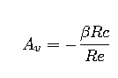
where β is the transistor current gain.

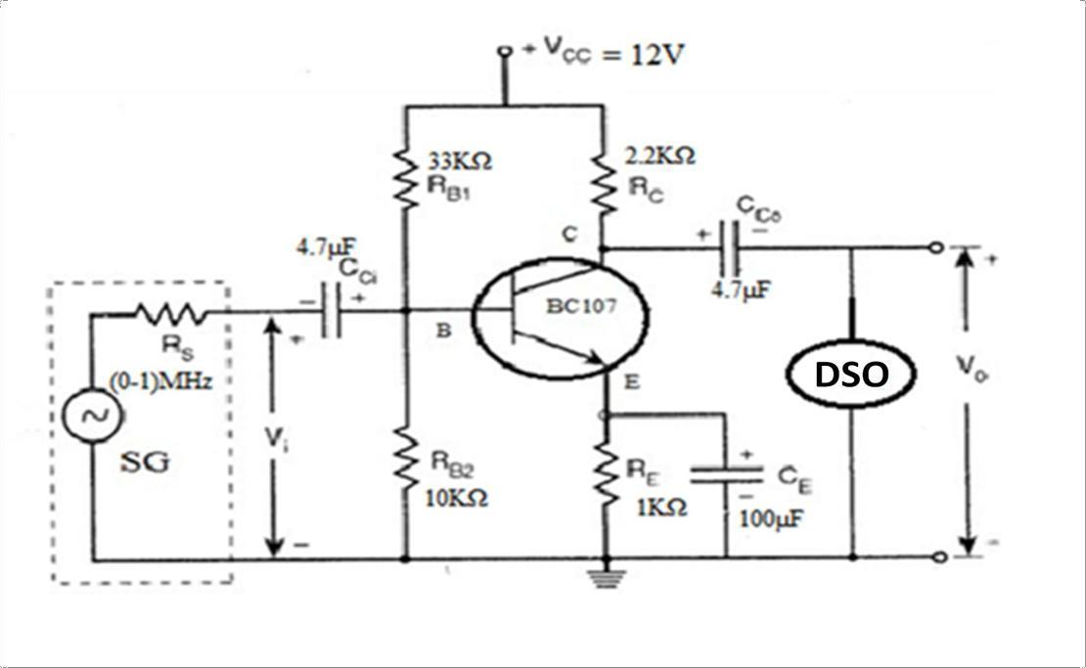
CIRCUIT DIAGRAM

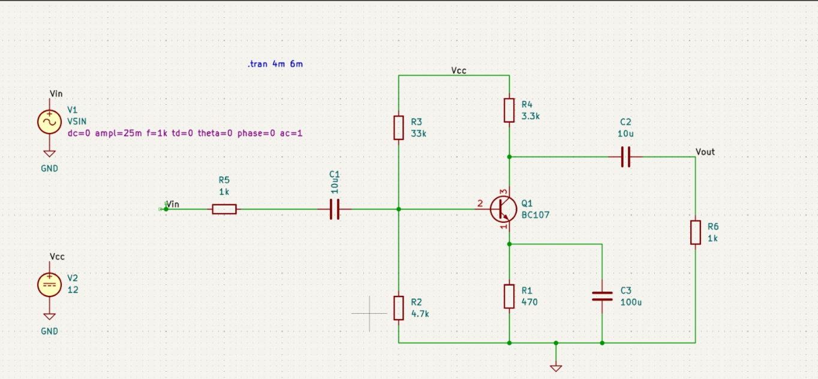

Waveforms:
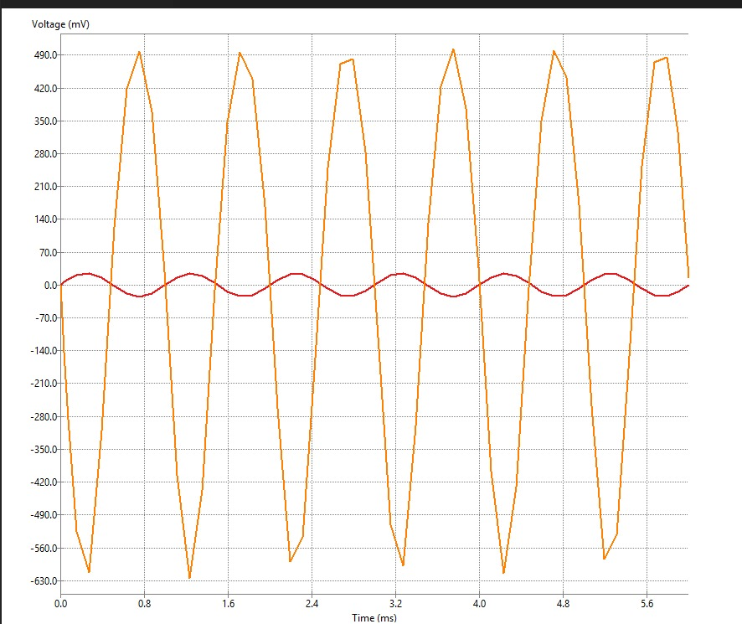
PROCEDURE
Step 1: Design and Simulation
- Select a transistor (BC107) and determine biasing values.
- Draw the schematic using simulation software (KICAD).
- Run the simulation to check gain and performance.
Step 2: Breadboard Implementation
- Assemble the circuit on a breadboard.
- Apply a small AC signal (e.g., 1kHz sine wave).
- Measure the output waveform using an oscilloscope.
- Verify the gain and functionality.
Step 3: PCB Design
- Open KiCad/Eagle/Altium and create a new PCB project.
- Import the schematic and assign footprints to components.
- Arrange components to minimize noise and enhance performance.
- Route the PCB tracks, ensuring proper grounding.
- Generate Gerber files for PCB fabrication.
Step 4: PCB Fabrication
- Print the PCB layout on a copper-clad board using a toner transfer method.
- Etch the board using Ferric Chloride (FeCl₃) solution.
- Drill holes and solder components onto the PCB.
PRECAUTIONS
- Ensure correct polarity of capacitors.
- Use heat sinks if required for high-power applications.
- Check PCB connections before soldering.
OBSERVATIONS
- Compare the simulated vs. practical gain.
- Measure input and output signals using an oscilloscope.
- Observe distortion, noise, and stability.

RESULT
Thus the schematic of a single-stage amplifier was designed and its PCB layout was designed using industry-standard tools (e.g., KiCAD) and the design for fabrication was prepared.

